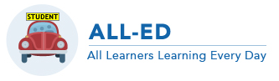
MOTIVATION 101

Defining motivation
What moves you to act? What makes you invest time and energy in one task but not another? These are the kinds of questions that concern motivational researchers. Researchers generally define motivation as something that influences or explains:
- why a person will start a task;
- whether or person will approach or avoid a task;
- how much effort a person will put into a task;
- whether or not a person will continue to work on the task once they start

What it’s not
Often, we hear from teachers that “my students are simply not motivated”. In other words, there is a tendency for teachers to think of motivation as a personality trait – students either have it or they don’t. Although it is certainly possible to identify students who appear more or less motivated in a classroom through their behavior, it is important to note that motivation is NOT a personality trait.

Consider yourself. I bet you that there are times when you feel like you can take on the world. This probably happens when you feel empowered and supported, competent, and generally love what you’re doing. Now, I’m sure that there are times when you don’t feel this way – why is that? Is it because you feel less competent? Less supported? Less empowered? Or maybe you simply don’t value what you’re working on?

Now let’s go back to the student(s) that appear unmotivated in your class. Take them out of your classroom and place them in a setting where they’re working on something that they love to do – maybe it’s an athletic field, maybe it’s at their place of work… If you observed them there, I bet you will see a totally different child. Again, motivation is not a personality trait.

One way to think about motivation is to consider attend to three student needs: Autonomy, Belonging, and Competence (Andreman & Leake, 2005). The ABCs of motivation are keys to designing instruction to engage, value and stretch all learners.

Anderman, L. H., & Leake, V. S. (2005). The ABCs of motivation: An alternative framework for teaching preservice teachers about motivation. The Clearing House, 192-196.
Jot-down Ideas that are Useful for You

Rank your ideas from easiest (1) to hardest (3) to use in your teaching.

Top 10 Facts about Motivation
http://all-ed.org
Akane Zusho and Rhonda Bondie
zusho@fordham.edu rbondie@fordham.edu

- Motivation is changeable – it is not a personality trait. Altering the task or the general learning environment can change it.

- Competence is at the core of motivation. When you feel like you can do the work, you’re more likely to do it.

- But… sometimes it’s not enough to feel like you can do the work. You must also value it in some way – maybe it’s something that interests you, or something that you find useful for future goals (e.g., job, college).

- When students perceive the task to be relevant to their lives, they are more likely to value the task.

- When you are placed in a setting where you feel autonomous (or empowered), competent, and that you belong, you are more likely to feel intrinsically motivated.

- The quality of behavior is generally much better when an individual feels intrinsically as opposed to extrinsically motivated. In other words, you’re more likely to put in more effort, persist longer, and learn more when the source of the motivation is yourself not others.

- Although other people can be powerful motivators, it is generally better to decrease social comparison if you want all students to be motivated. Social comparison generally works as a motivator for stronger students; for weaker students, it is usually a deterrent. In other words, don’t set others as the standard; set the task as the standard (e.g., don’t grade on a curve).

- Rewards can be tricky. Simple extrinsic rewards generally do not promote lasting motivation. If you want to sustain motivation, it’s much more important to find ways to get students to value the task and feel more competent about what they’re working on. Rewards can backfire if they’re not equitable (so everyone feels like they all have a chance to get them), if they don’t make students feel competent about what they’re doing, and if students don’t feel in control (i.e., teacher is dangling a carrot on a stick).

- Students are more likely to be intrinsically motivated when they know what they know and do not know. In other words, there is a symbiotic relationship between motivation and self-regulated learning.

- Given this research, ALL-ED routines of group learning, self-regulation, and planning with clarity, access, rigor, and relevance are central to fostering motivation.

SELF-REGULATED LEARNING 101
http://all-ed.org
Akane Zusho and Rhonda Bondie
zusho@fordham.edu rbondie@fordham.edu
Defining Self-Regulated Learning
When it comes to tackling academic tasks, are you aware of how you learn? Do you know what your strengths and weaknesses are? Are you good at knowing what you know and don’t know? Do you know what kind of strategies help you to complete a given task successfully? Before working on a task, do you set appropriate goals? While working on the task, do you monitor how you’re doing and whether or not you need to change your strategies? When you encounter an obstacle, do you figure out ways around it? Once you complete a task, do you reflect on what you’ve learned and what you may need to do to improve your performance the next time around?
These are the kinds of questions that concern researchers who study self-regulated learning (SRL). Although there are a number of theoretical models of SRL, they all define SRL as a constructive process whereby learners proactively activate, monitor, control, and regulate their thoughts, feelings, and behaviors to achieve self-set learning goals (Zimmerman, 1990).
Top 10 Facts About SRL
- Self-regulated students – that is students who reflect on their thinking, set appropriate goals and plan for learning, monitor progress towards those goals, and adjust or regulate their thinking, motivation, and study habits – are more likely to achieve academic success than those who do not (Pintrich & Zusho, 2007; Zimmerman, 1990).

- SRL skills are learned skills that can be modified and improved, thus making it an ideal target for intervention at any age level.

- The use of SRL-related strategies (e.g., goal-setting, monitoring, evaluating) should improve performance in any subject domain (e.g., reading, writing, mathematics, chemistry, biology, psychology, and even physical education).

- Students who feel more confident (but not overconfident) about the subject and their academic skills are more likely to use self-regulatory strategies.

- For students to regulate their learning effectively, they must also have adequate knowledge about the task and its requirements, the subject domain, and knowledge of strategies.

- Students are more likely to regulate their learning when they have adequate resources available, including time, effective and supportive teachers and peers, as well as access to supplementary learning materials.

- The use of SRL strategies is strongly associated with a growth mindset.

- Students are more likely to regulate their learning when they are prompted to do so, either directly (through instruction) or indirectly (through feedback or activity prompts).

- Differentiated instruction is easier when students support the effort by assessing their progress, seek help when needed, and pursue learning goals independently.

- The ALL-ED routines of group learning, self-regulation, and planning with clarity, access, rigor, and relevance are central to fostering self-regulated learners.
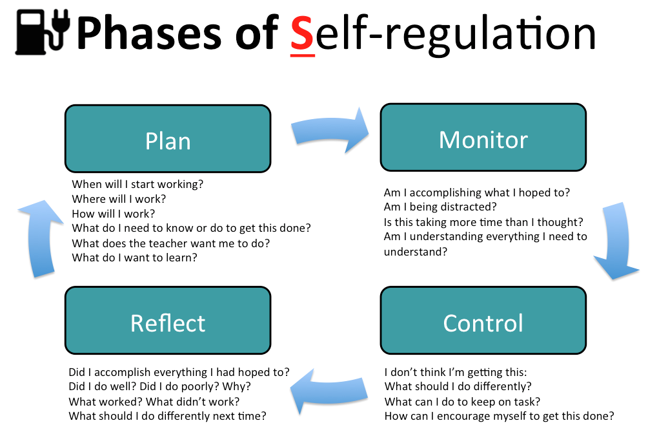

Find the Self-Regulation in this Note Taking Guide
Today’s Topic
__________________________________________________________________________
New Vocabulary | Important Information  + learned or confirmed | Ideas
Questions I have

Today’s Topic relates to our Essential Question because…

Today’s Topic made me think of…

“TODAY I…” (Circle all that apply)
Helped a classmate Asked for help Stayed on task Had fun
Followed Directions Arrived On Time Was prepared to learn

My next steps are to:
T-Chart with Self-Regulation Prompts
Topic: Self-Regulated Learning

I think that I know Questions that I have

Revisit this chart as you learn more.
Place a check next to things that are confirmed.
Cross out things that you no longer think or question.
Place a question mark next to things that you would like to find out more about.
Add new ideas.

